NORTH WEST LITTLE LEAGUE
Return to Play
Covid-19 Safety Plan
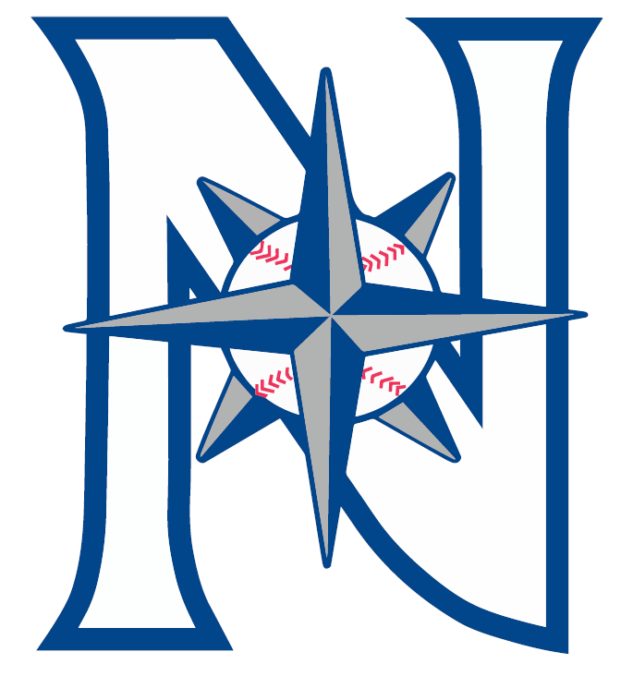

North West Little League
Return to Play: Covid-19 Safety Plan
Table of Contents

SECTION 1: Considerations & Assumptions 4
SECTION 2: Activities & Assumptions 5
SECTION 3: Health & Hygiene 5
SECTION 4: Safety & Physical Distancing 6
SECTION 5: Administrative Considerations 6
Appendix 1: Screening Form 8
Appendix 2: Zero Tolerance Policy 10
Appendix 3: Contract Tracing sign-in sheet 12
Appendix 4: Cleaning & Sanitization Procedures 13

SECTION 1: Considerations & Assumptions

- Signs and verbal reminders will emphasize that anyone who is sick or has anyone in their household with cold-like symptoms such as cough, fever, runny nose, sore throat or shortness of breath, MUST NOT be in attendance and must leave the designated play area immediately.
- Patrons with these symptoms will not be allowed to participate and will be advised to return home.
- A responsible person from each team will ensure all volunteers and players complete daily screening for symptoms and close contact with persons with COVID-19 through the screening checklist which is attached as Appendix 1 or the Health Check on TeamSnap. To enable quick contact with participants and patrons, a responsible person on each team will maintain a sign-in list for anyone attending the activity. TeamSnap will be used and supplemented by a sign-in sheet (Appendix 4).
- For the purposes of tracing close contacts, the responsible person will maintain a sign-in list and will provide this info to the NWLL Safety Officer, Lisa Turner (lisa@nwll.ca) upon request:
  - who was working or playing onsite at any given time block;
  - all volunteers and coaches who may have worked with players at any given time block;
  - Anyone who was at the activity at a given time.
- We will encourage players and parents to wear face coverings in accordance with the current restrictions in place by the Alberta Government.
- Spitting is not permitted. Tobacco use of any kind, gum, unshelled sunflower seeds, and unshelled peanuts are not permitted at any event. Anyone found with these items will be asked to put them away or leave the area.
- Each game will have designated “spotters” volunteers to watch for unsafe behaviours or to identify equipment that requires cleaning. Spotters will communicate with their respective coaches who will then communicate with participants and umpires. Players need to be educated and reminded on a continual basis about the safety measures.
- All teams will have a coach (who is over the age of 18) to player ratio of 1:10 or 2:15, and social distancing will be a key strategy to these fun, interactive opportunities for youth.
- If a participant, coach or volunteer develops COVID-19 symptoms during the activity, they should be sent home to begin isolation immediately.
- In the event that a participant requires first aid, a family member will attend to the injured. If not possible, the first aider should use appropriate Personal Protective Equipment, including medical mask and gloves.
- Protocols for safety of a participant with a disability will be put in place if needed.

SECTION 2: Activity Protocols

- Players are encouraged not to touch their face or put any part of their hands in their mouth. Pitchers are not allowed to put their fingers to their mouth.
- Anytime a baseball leaves the playing field, it needs to be cleaned and sanitized before it can be used again. Any equipment that must be shared between players must be cleaned and sanitized between use, and before and after each activity. See Appendix 5 for cleaning and sanitization procedures.
- Coaches will sanitize hands and practice hand hygiene prior to handling baseballs.
- Coaches, umpires and players may wear their own masks when physical distancing is unable to be maintained.
- No dugout use will be permitted. Players will spread out their gear along fences.
- NWLL will abide by Little League Alberta’s outline of drills, practice plans, and activities that show our ability to offer these programs following proper social distancing measures.
- Participants are expected to come dressed to play and are encouraged to provide and use their own equipment wherever possible.
SECTION 3: Health & Hygiene
- Any porta-potties available at the diamonds will be maintained in a clean and sanitary condition and remain locked. Cleaning and disinfection will occur at the start of any event.
- All porta-potties will be stocked with an adequate supply of paper towel, toilet paper, and hand sanitizer.
- Regular household cleaning and disinfecting products are effective against COVID-19 when used according to the directions on the label.
  - NWLL will use a disinfectant that has a Drug Identification Number (DIN) and a virucidal claim (efficacy against viruses) or a bleach-water solution with 100 ml of bleach to 900 ml water.
  - NWLL will make disposable towels and spray cleaners, or disposable wipes, available to team volunteers and (as necessary) participants to regularly clean commonly used surfaces.
- NWLL will use a “wipe-twice” method to clean and disinfect. First wipe is to clean surfaces with a cleaning agent and cloth to clean off soil, and then they are to be wiped again with a disinfectant. Key factors in ensuring the equipment is properly cleaned and disinfected include:
  - cleaning any visible soiling of the surface;
  - full coverage of surfaces in disinfectant;
  - use friction when cleaning and disinfecting. This helps ensure all areas are covered & to help destroy and remove any viruses or bacteria.
- All participants must clean and disinfect their equipment after each event and prior to the next one (preferably 24 hours apart).
- Participants must wear clean clothing/uniforms to each event. Uniforms must be cleaned after each event and prior to the next one.
- All teams must clean, disinfect, and not use for 24 hours any equipment they may sign out to individuals before the first use of said equipment.
- Baseballs must be sanitized before and after each event, and prior to being re-entered into games or practices. Sanitization should use recommended products to ensure the maximum safety.
- NWLL will promote and facilitate frequent and proper hand hygiene for all volunteers and patrons. NWLL will instruct participants and volunteers to wash their hands often with soap and water for at least 20 seconds or use an alcohol-based hand sanitizer (greater than 60% alcohol content).
- NWLL will provide a means to sanitize hands at the start of all games and practices and as needed throughout the event.
- Hand washing with soap and water is required if the employee or volunteer has visibly dirty hands.
SECTION 4: Safety and Physical Distancing
- Bleacher seats will be marked with “Do not use due to Social Distancing Restrictions” posters to assist in facilitating this procedure.
- No physical contact (handshakes, fist bumps, high 5’s, etc) at any time including between players, and between players and coaches.
- No gathering around the park until your scheduled arrival time. Please remain in your own vehicle until 5 minutes before your scheduled arrival time.
- All participants/patrons must leave the area immediately following the conclusion of the event. Post-game meetings are encouraged to be done via video conference call on apps like Skype, Zoom, House Party, etc once everyone has arrived home safely.
- Maintaining a 2 metre separation between individuals social distancing (e.g., volunteers, patrons) is mandatory
- Spectators are not allowed to enter designated participant-only spaces.
SECTION 5: Administrative Considerations
- We will conduct training sessions with organization board members, umpires, coaches, players, and parents to explain re-opening conditions.
- No sharing of cell phones, clothing items, or personal items. If someone does not have a phone, that person must go to the leader/coach who will make the phone call on behalf of said person. Also, cell phones should be disinfected prior to arriving at the facility and at the first opportunity when you arrive home.
- No sharing of water bottles or food of any kind. Water/beverages should be brought from home. Please ensure water bottles are labelled with participant name.
- Email communication will be sent regarding all protocols and expectations to all participants and parents in advance.
- Website and social media will contain resources and protocols for these programs.
- Members will be expected to read and acknowledge the updated Zero Tolerance Policy on new provisions related to COVID-19 baseball relaunch.
- All Equipment needs to be assigned to the individual or owned by the individual. No sharing of equipment is permitted unless it has been cleaned, disinfected, and not used for 24 hours.

- Volunteers will make every effort to encourage and educate on respiratory etiquette (e.g., coughing or sneezing into a bent elbow, promptly disposing of used tissues in the trash, and followed by hand hygiene) is followed.
- Ride sharing (car-pooling) is not recommended. Players should travel only with an immediate family member. If necessary, a pod of two families can be created (only includes immediate family members of two nearby families) to assist in getting each other’s children to the game/practice, but group car-pooling is not recommended or endorsed in any way.
- Signage will be posted as reminders of how to mitigate risks of COVID-19 transmission (e.g., hand hygiene, respiratory etiquette).
- Signage with information that maintaining social distancing at all times will be posted.

Appendix 1: Screening Form
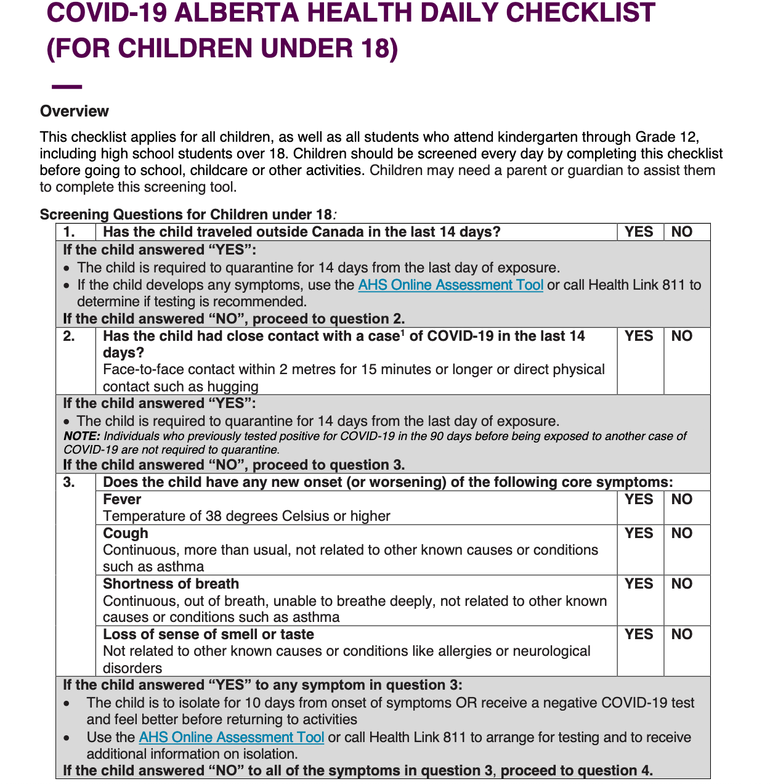

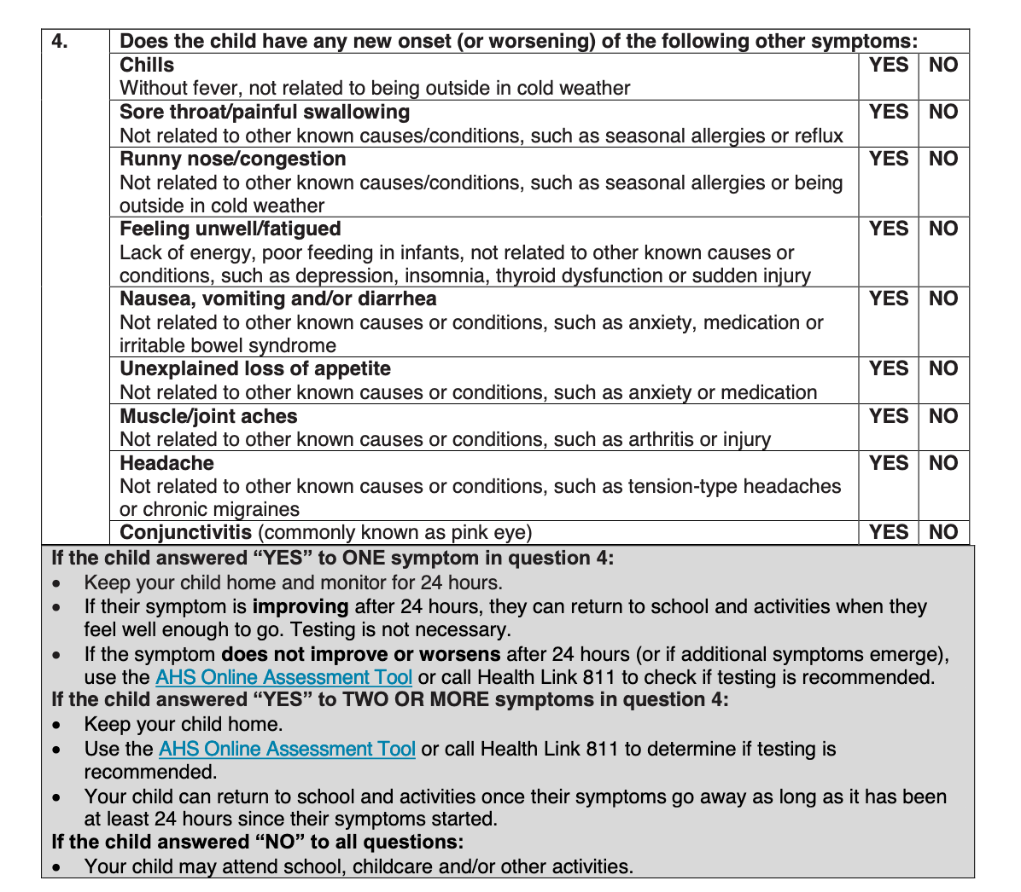

Appendix 3: Little League Alberta Zero Tolerance Policy

North West Little League (NWLL) believes all participants in Little League baseball deserve to be treated with respect. Players and game officials are learning the game. Coaches and managers are volunteers. In order to create an environment that allows all participants to learn and grow, NWLL will impose and enforce a Zero Tolerance Policy with respect to abuse of any participant, coach, manager, official, player or parent/fan.
Abuse will be defined as any form of physical, emotional and/or sexual mistreatment or lack of care which causes physical injury or emotional damage to a child. A common characteristic of all forms of abuse against children and youth is an abuse of power or authority and/or breach of trust. In Alberta a person is considered a child up to the age of 18 years.
Emotional abuse is a chronic attack on a child's self-esteem; it is psychologically destructive behavior by a person in a position of power, authority or trust. It can take the form of name-calling, threatening, ridiculing, berating, intimidating, isolating, hazing or ignoring the child's needs.
Physical abuse is when a person in a position of power or trust purposefully injures or threatens to injure a child or youth. This may take the form of slapping, hitting, shaking, kicking, pulling hair or ears, throwing, shoving, grabbing, hazing or excessive exercise as a form of punishment.
The NWLL Zero Tolerance policy will include any abuse against adults including that which may cause emotional distress for our players, officials and fans.
Any ejection for abuse will automatically result in a 3-game suspension, with the game in question counted as the first game. In the event the abuse comes from outside the playing field, a written complaint must be formally lodged with a league executive. The complaint may be lodged by any player, coach, game official, or observer and the offending party will be asked not to attend the next three games.
Any confrontation that escalates to physical violence defined as “intentional physical contact with force” will result in a suspension, the minimum being one-year suspension from all little league parks within the boundaries of NWLL to a maximum lifetime suspension. Physical violence shall include but not be limited to pushing, punching, tripping, kicking or hitting with any object including a person’s hand or any part of their body.
The zero tolerance policy is enhanced in 2020 due to COVID-19. We expect all persons to respect social distancing guidelines and any other health protocols required when you are in attendance in any capacity at a Little League function. You will be asked to leave the facility if you do not respect these safety protocols that have been put in place.
Any person subject to a suspension shall be entitled to a hearing before a committee convened to rule on the validity of the complaint. At such a committee meeting the ejected party shall have the right to hear all charges, read any written complaints and defend his/her position to the committee. In the event that any individual cannot attend the hearing, that individual may designate someone to speak on their behalf or provide a written statement to the committee. Should any individual pass on attending or participating in the opportunity to defend him/herself the committee reserves the right to rule based on the material before them. The committee retains the right to impose sanctions for the good of NWLL Baseball, including its players, coaches, managers, game officials and fans. The decision of the hearing committee will be final.

The hearing committee will consist of the following representatives or their designates:

- The District Administrator;
- District Umpire in Chief/Tournament umpire in chief;
- District interlock co-ordinator/Tournament co-ordinator;
- 2 league presidents independent of the league(s) involved in the hearing.

The disciplinary hearing should take place within 5 days of the incident.
The following parties shall be entitled to attend the disciplinary hearing to answer questions from the committee:
- The parties involved in the incident under review;
- Witnesses on behalf of each party;
- Any game or league official who witnessed the incident;
- In the event a player is involved a parent will be encouraged to attend.
The hearing will proceed as follows:
- The committee members will convene and select a chair from among the members present;
- The accused or his/her representative will be asked to be present;
- The official complaint shall be read into the record or heard from the accuser;
- The accused party shall have an opportunity to respond;
- The accuser will be allowed to call witnesses one at a time who the hearing committee chair shall ask for his / her evidence;
- The accused will be allowed to call witnesses one at a time who the hearing committee chair shall ask for his / her evidence;
- Once the hearing committee is satisfied it has the information it requires the hearing will be adjourned;
- The committee will reconvene without any witnesses to render a decision in the matter within five days, the decision will be delivered in writing to the accused and copied to the executive of the league involved;
- All non-party witnesses must remain outside.
The decision will be final and binding. Should new information come to light the committee reserves the right to recall the issue based on a majority vote of the original members of the hearing committee.

Appendix 4: Contract Tracing Sign-In
Date: Start Time: End Time: Type of Event: Game / Practice

Last name | First name | Number of people in your family or group | Completed self-assessment for all attendees? | Responsible contact person phone number

** Personal information is collected only for the purposes of contact tracing and will not be used for any other purpose. Information will be destroyed 14 days after the event listed above.

Appendix 5: Cleaning & Sanitation Procedure
This procedure applies to any shared personal equipment (e.g., umpire or catcher gear, bats, helmets) prior to being used by the next person, and to all high-touch equipment (e.g., baseballs). Baseballs are to be cleaned and sanitized at each stoppage in play. Each team shall be provided with a cleaning kit consisting of:
- Bucket (to hold contents)
- Spray bottle with diluted, ready to use cleaning agent (e.g., dish soap)
- Spray bottle with approved disinfectant or pre-moistened disinfectant wipes
- Disposable cloths (blue shop towels)
- Reusable rubber dishwashing gloves (2 pairs)
- Hand sanitizer - at least 60% alcohol (2 bottles)
Volunteer cleaner(s) must be identified by the team at each practice or game to be responsible for cleaning and sanitizing. Volunteers will use a “wipe twice” method to clean and disinfect. Cleaning refers to removal of visible soil. Cleaning does not kill germs but is highly effective at removing them from a surface. Disinfecting refers to using a chemical to kill germs on a surface and is only effective AFTER a surface has been cleaned.
Volunteer cleaners must use hand sanitizer, then wear gloves prior to beginning cleaning. Volunteer cleaners must not share gloves and should refrain from touching their face or other surfaces with gloves.
Wipe Twice Method:
- Spray equipment generously with a cleaning agent and use disposable cloth to clean off dirt or other soiling. Use of friction ensures the surface is cleaned.
- Once cleaned, spray or wipe equipment with a disinfecting agent. Allow to air dry.
Volunteer cleaners should clean and disinfect their gloves and spray bottles after cleaning and ensure all supplies are returned to the bucket for the next event.

